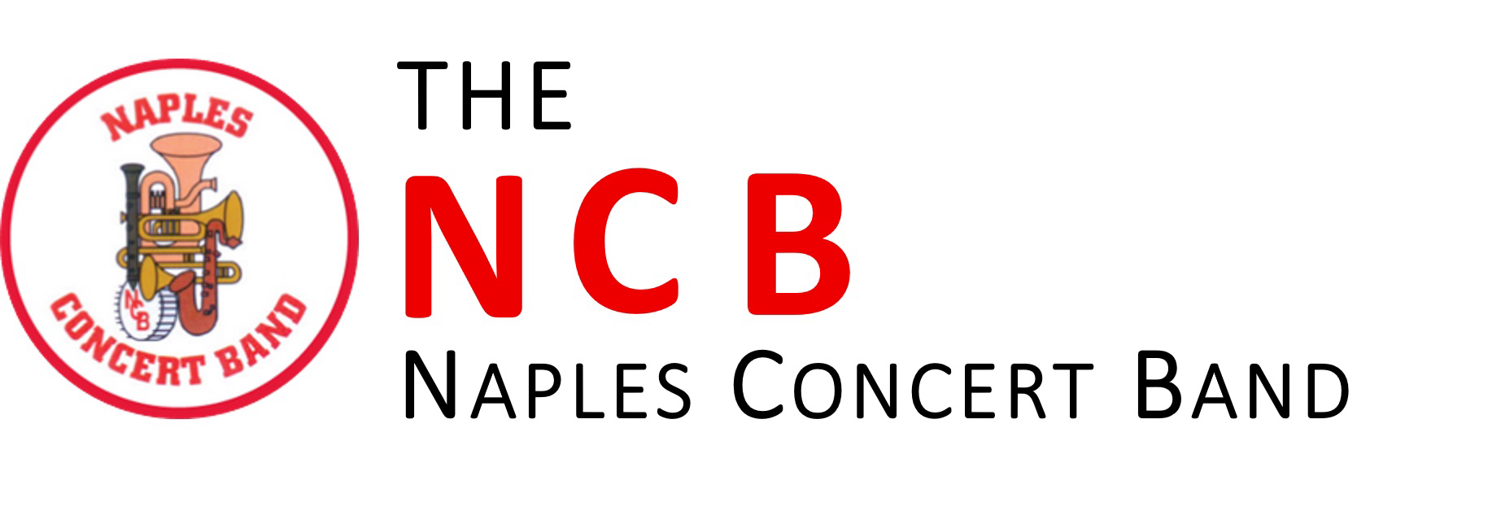

Audition:
A short audition is required for membership in the Naples Concert Band. For audition requirements and to schedule your audition please email our membership coordinator Lorraine Wistrom, l.wistrom@comcast.net.

*There is a limited instrumentation and membership is determined upon availability. Exceptions may be granted at the discretion of the Music Director.

Rehearsals:
Rehearsals are held at the Emmanuel Lutheran Church Family Life Center (777 Mooring Line Dr, Naples, FL 34102) from 6:30 to 9:00p.m. every Tuesday during the concert season.

Performances:
Performances are held in the Cambier Park Band Shell (755 8th Ave S, Naples, FL 34102) on selected Sundays at 2:00p.m.

